Question1:Develop a GUI-based banking application that allows users to perform operations such as fund transfer, balance inquiry, and viewing transaction history. Use Swing components and event listeners to manage user interactions securely. Implement input validation for sensitive data like account number and amount. Ensure proper error handling for invalid transactions. Apply suitable layout managers to create a responsive and user-friendly interface. Analyze system responsiveness during multiple operations and suggest improvements. Demonstrate how secure input handling enhances reliability
Code :
import javax.swing.*;
import java.awt.*;
public class Main extends JFrame {
double balance = 10000;
JTextField account, amount;
JTextArea history;
Main() {
setTitle("Banking Application");
setSize(500, 400);
setLayout(new GridLayout(5, 2, 10, 10));
setDefaultCloseOperation(JFrame.EXIT_ON_CLOSE);
add(new JLabel("Account Number:"));
account = new JTextField();
add(account);
add(new JLabel("Amount:"));
amount = new JTextField();
add(amount);
JButton transfer = new JButton("Fund Transfer");
JButton check = new JButton("Balance Inquiry");
JButton view = new JButton("Transaction History");
add(transfer);
add(check);
add(view);
history = new JTextArea();
add(new JScrollPane(history));
transfer.addActionListener(e -> transferMoney());
check.addActionListener(e ->
JOptionPane.showMessageDialog(this,
"Current Balance: ₹" + balance));
view.addActionListener(e ->
JOptionPane.showMessageDialog(this,
history.getText()));
setVisible(true);
}
void transferMoney() {
try {
String acc = account.getText().trim();
double money = Double.parseDouble(amount.getText());
if (!acc.matches("\\d{10}"))
throw new Exception("Account number must be 10 digits");
if (money <= 0)
throw new Exception("Amount must be greater than 0");
if (money > balance)
throw new Exception("Insufficient balance");
balance -= money;
history.append("Transferred ₹" + money +
" to A/C " + acc + "\n");
JOptionPane.showMessageDialog(this,
"Transfer Successful!");
account.setText("");
amount.setText("");
} catch (NumberFormatException e) {
JOptionPane.showMessageDialog(this,
"Enter a valid amount!",
"Error", JOptionPane.ERROR_MESSAGE);
} catch (Exception e) {
JOptionPane.showMessageDialog(this,
e.getMessage(),
"Error", JOptionPane.ERROR_MESSAGE);
}
}
public static void main(String[] args) {
SwingUtilities.invokeLater(() -> new Main());
}
}
Output:
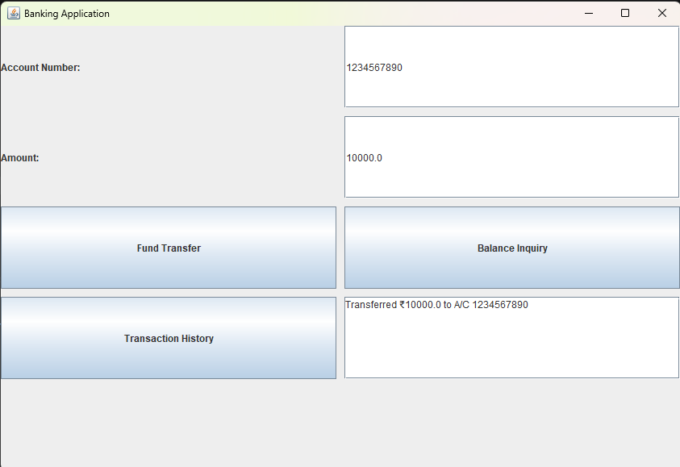

Question2: Design a Swing-based GUI application for a hospital to manage patient appointments, including booking, updating, and canceling schedules. Use AWT/Swing controls such as buttons, text fields, tables, and menus to facilitate user interaction. Implement event listeners to handle actions like appointment confirmation and deletion. Ensure the system can handle dynamic patient data efficiently. Evaluate different layout managers (FlowLayout, GridLayout, BorderLayout) for organizing complex UI components. Analyze how the design supports scalability when the number of patients increases. Propose improvements for better usability and real-time updates.

Code:
import javax.swing.*;
import java.awt.*;
public class Main extends JFrame {
double balance = 10000;
JTextField account, amount;
JTextArea history;
Main() {
setTitle("Banking Application");
setSize(500, 400);
setLayout(new GridLayout(5, 2, 10, 10));
setDefaultCloseOperation(JFrame.EXIT_ON_CLOSE);
add(new JLabel("Account Number:"));
account = new JTextField();
add(account);
add(new JLabel("Amount:"));
amount = new JTextField();
add(amount);
JButton transfer = new JButton("Fund Transfer");
JButton check = new JButton("Balance Inquiry");
JButton view = new JButton("Transaction History");
add(transfer);
add(check);
add(view);
history = new JTextArea();
add(new JScrollPane(history));
transfer.addActionListener(e -> transferMoney());
check.addActionListener(e ->
JOptionPane.showMessageDialog(this,
"Current Balance: ₹" + balance));
view.addActionListener(e ->
JOptionPane.showMessageDialog(this,
history.getText()));
setVisible(true);
}
void transferMoney() {
try {
String acc = account.getText().trim();
double money = Double.parseDouble(amount.getText());
if (!acc.matches("\\d{10}"))
throw new Exception("Account number must be 10 digits");
if (money <= 0)
throw new Exception("Amount must be greater than 0");
if (money > balance)
throw new Exception("Insufficient balance");
balance -= money;
history.append("Transferred ₹" + money +
" to A/C " + acc + "\n");
JOptionPane.showMessageDialog(this,
"Transfer Successful!");
account.setText("");
amount.setText("");
} catch (NumberFormatException e) {
JOptionPane.showMessageDialog(this,
"Enter a valid amount!",
"Error", JOptionPane.ERROR_MESSAGE);
} catch (Exception e) {
JOptionPane.showMessageDialog(this,
e.getMessage(),
"Error", JOptionPane.ERROR_MESSAGE);
}
}
public static void main(String[] args) {
SwingUtilities.invokeLater(() -> new Main());
}
}
output:
